**RAID**

Redundant Array of Independent Disks (RAID) is a storage technology that creates a data loss fail-safe by merging two or more hard disk drives (HDDs) or solid-state drives (SSDs) into one cohesive storage unit, or array.

RAID storage protects against the total loss of a disk drive’s data by repeating or recreating that data and storing it on the additional drive or drives, a process also known as [data redundancy](https://www.defit.org/data-redundancy/).

[Total data loss](https://www.techopedia.com/definition/29863/data-loss), which may occur in the event of a disk drive failure, can devastate businesses and organizations that require frequent access to stored information to carry out their daily responsibilities.

**Types of RAID**

Implementation and management of RAID storage can be executed via software RAID, whereby a driver on a computer executes RAID processing, or by hardware RAID, whereby a RAID controller card utilizing a motherboard’s [PCI Express](https://www.trentonsystems.com/blog/speed-differences-pcie-4-vs-3) slot is used.

The effectiveness of software RAID depends on the processing power of the computer. It’s not ideal for complex RAID configurations.

For those high-performance configurations, you’ll need a dedicated RAID controller, the sole purpose of which is to execute RAID processing.

Average desktop users can get by with software RAID, since most operating systems, including Apple and Windows, support RAID. Plus, software RAID is the cheaper option. Bigger, more complex RAID applications, however, will need to go with hardware RAID to achieve the highest possible performance.

**Raid 0: Striping**

Requiring a minimum of two disks, RAID 0 splits files and stripes the data across two disks or more, treating the striped disks as a single partition. Because multiple hard drives are reading and writing parts of the same file at the same time, throughput is generally faster.

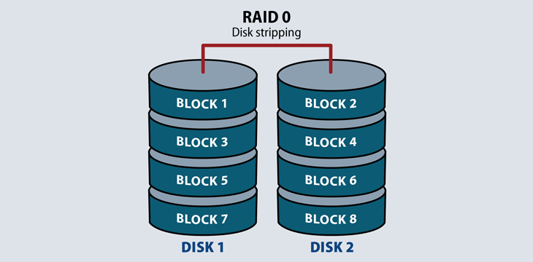

RAID 0 does not provide redundancy or fault tolerance. Since it treats multiple disks as a single partition, if even one drive fails, the striped file is unreadable. This is not an insurmountable problem in video streaming or computer gaming environments where performance matters the most, and the source file will still exist even if the stream fails. It is a problem in high availability environments.

### ****RAID 1: Mirroring****

RAID 1 requires a minimum of two disks to work, and provides data redundancy and failover. It reads and writes the exact same data to each disk. Should a mirrored disk fail, the file exists in its entirety on the functioning disk. Once IT replaces the failed desk, the RAID system will automatically mirror back to the replacement drive. RAID 1 also increases read performance.

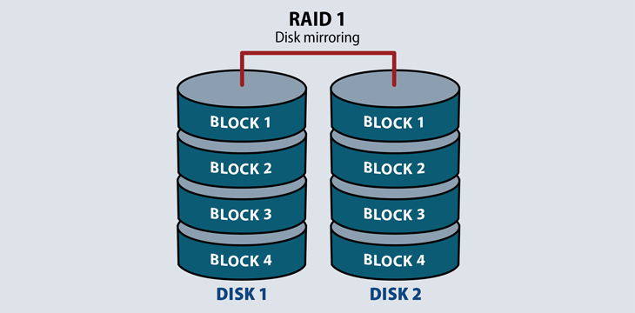

It does take up more usable capacity on drives, but is an economical failover process on application servers.

### ****Raid 5: Striping with Parity****

This RAID level distributes striping and parity at a block level. Parity is raw binary data. The RAID system calculates its values to create a parity block, which the system uses to recover striped data from a failed drive. Most RAID systems with parity functions store parity blocks on the disks in the array. (Some RAID systems dedicate a disk to parity calculations, but these are rare.)

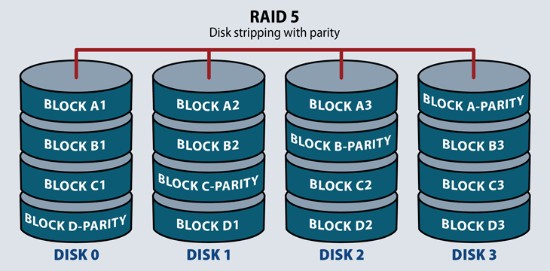

RAID 5 stores parity blocks on striped disks. Each stripe has its own dedicated parity block. RAID 5 can withstand the loss of one disk in the array.

RAID 5 combines the performance of RAID 0 with the redundancy of RAID 1, but takes up a lot of storage space to do it – about one third of usable capacity.

This level increases write performance since all drives in the array simultaneously serve write requests. However, overall disk performance can suffer from write amplification, since even minor changes to the stripes require multiple steps and recalculations.

### ****RAID 6: Striping with double parity****

This RAID level operates like RAID 5 with distributed parity and striping. The main operational difference in RAID 6 is that there is a minimum of four disks in a RAID 6 array, and the system stores an additional parity block on each desk. This enables a configuration where two disks may fail before the array is unavailable. Its primary usage case or application servers and large storage arrays.

RAID 6 offers higher redundancy than 5 and increased read performance. It can suffer from the same server performance overhead with intensive write operations. This performance hit depends on the RAID system architecture: hardware or software, if it’s located in firmware, and if the system includes processing software for high-performance parity calculations.

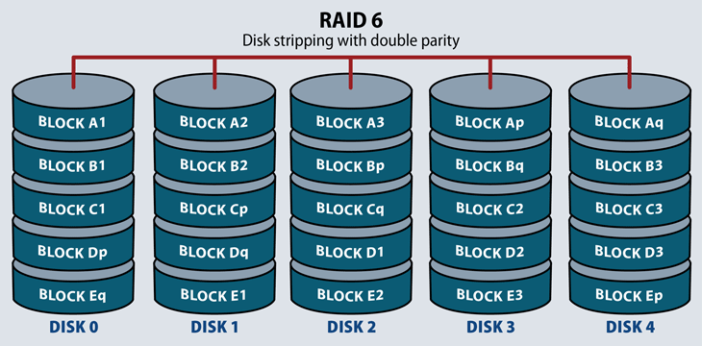

### ****RAID 10: Striping and Mirroring****

RAID 10 requires a minimum of four disks in the array. It stripes across disks for higher performance, and mirrors for redundancy. In a four-drive array, the system stripes data to two of the disks. The remaining two disks mirror the striped disks, each one storing half of the data.

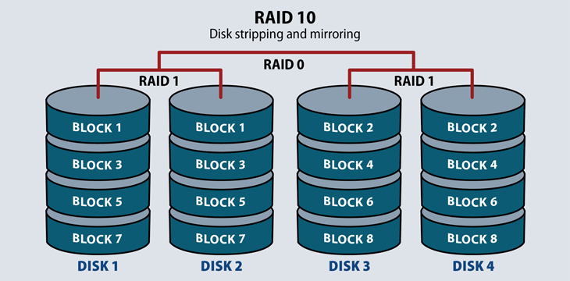

This RAID level serves environments that require both high data security and high performance, such as high transactional databases that store sensitive information. It is the most expensive of the RAID levels with lower usable capacity and high system costs.